Lytchett Minster and Upton Gardening Club
www.lmugc.org.uk

On Saturday 1st June 2019
We are holding our
‘Annual Spring Plant Sale’
At Upton Community Centre
from 10am – 12noon
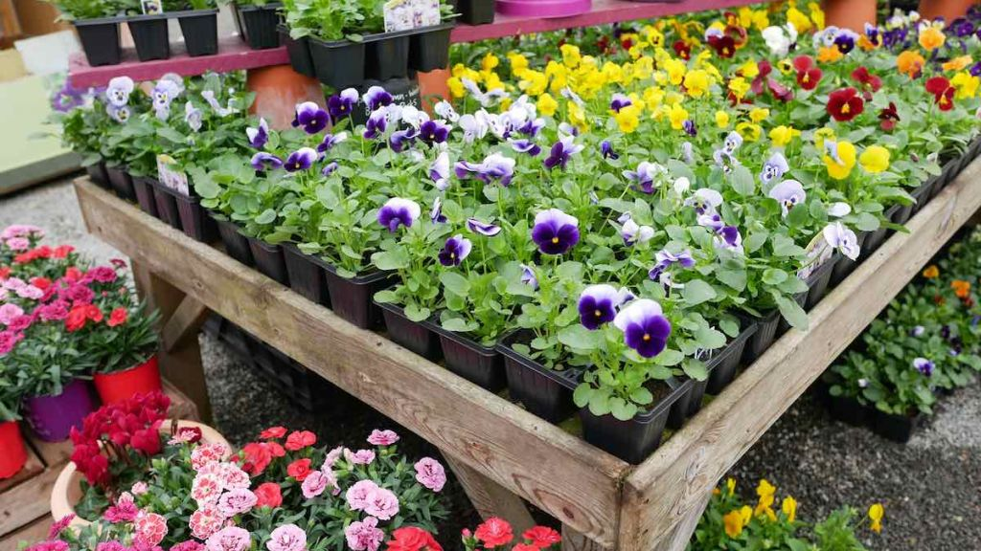
Come and buy your bedding plants and lots more!

