Lytchett Minster and Upton Gardening Club
www.lmugc.org.uk

On Thursday 26th September 2019
Julia Bridger
Will present
‘Keynston Mill’
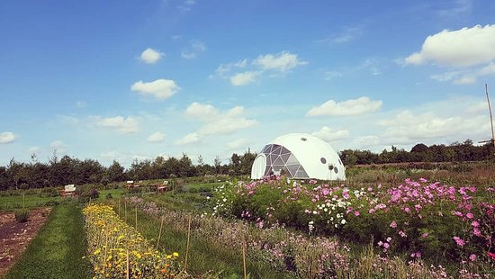

At Upton Community Centre at 7.30pm
(Non members are welcome to join us at £3 each,
(tea and biscuits included.)

