Lytchett Minster and Upton Gardening Club
www.lmugc.org.uk

On Thursday 27th June 2019
James Harper
(from the Watercress Farm)
will present
‘Wasabi’
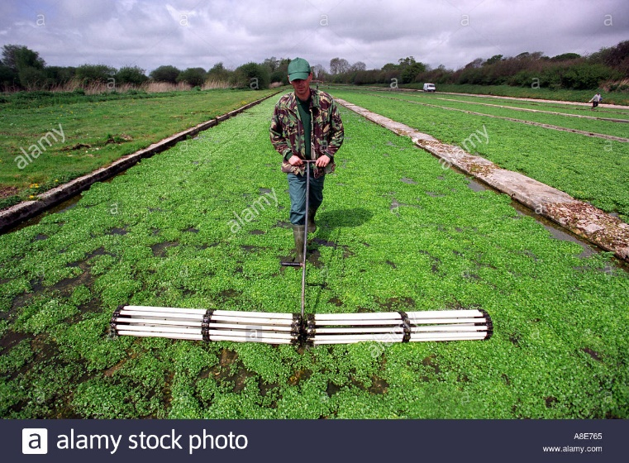

At Upton Community Centre at 7.30pm
(Non members are welcome to join us at £3 each,
(tea and biscuits included.)

