Lytchett Minster and Upton Gardening Club
www.lmugc.org.uk

On Thursday 25th April 2019
Bob Ayres
Will present
‘The Rivers of Dorset’
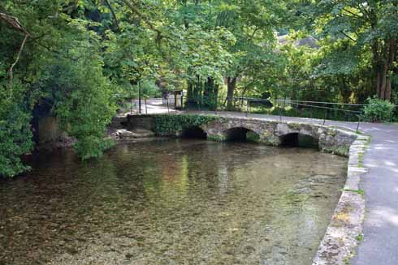
At Upton Community Centre at 7.30pm
(Non members are welcome to join us at £3 each,
(tea and biscuits included.)

