Lytchett Minster and Upton Gardening Club
www.lmugc.org.uk

On Thursday 28th March 2019
Louis Phillips
Will present
‘The Art and Science of Compost Making’
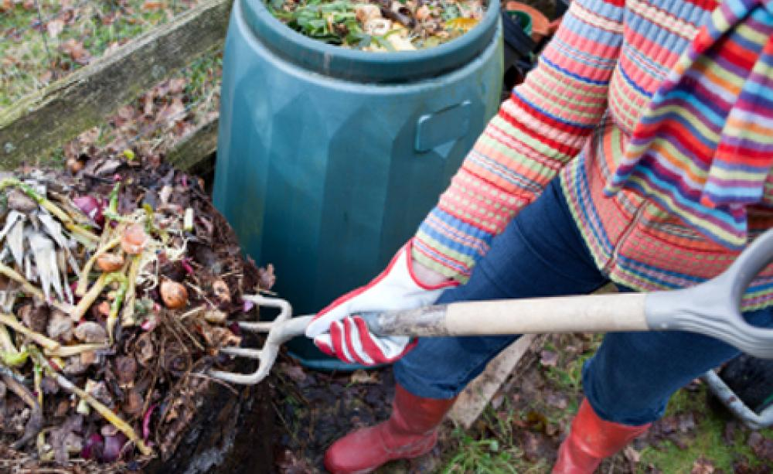
At Upton Community Centre at 7.30pm
(Non members are welcome to join us at £3 each,
(tea and biscuits included.)

