Lytchett Minster and Upton Gardening Club
www.lmugc.org.uk

On Thursday 24th October 2019
Mike Read
will present
‘Wildlife of a Working Forest’
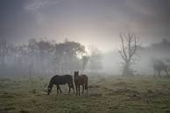

At Upton Community Centre at 7.30pm
(Non members are welcome to join us at £3 each,
(tea and biscuits included.)

